Article

A Smart System for Continuous Sitting Posture Monitoring and Assessment

David Faith Odesola 1, Janusz Kulon 1*, Shiny Verghese 1, Adam Partlow 2, and Colin Gibson 2

|  |
| --- |
| **Citation:** To be added by editorial staff during production.  Academic Editor: Firstname Lastname  Received: date  Revised: date  Accepted: date  Published: date    **Copyright:** © 2024 by the authors. Submitted for possible open access publication under the terms and conditions of the Creative Commons Attribution (CC BY) license (https://creativecommons.org/licenses/by/4.0/). |

1 Faculty of Computing, Engineering and Science, University of South Wales, Pontypridd, CF37 1DL, UK; 30025293@students.southwales.ac.uk; j.kulon@southwales.ac.uk; shiny.verghese@southwales.ac.uk

2 Rehabilitation Engineering Unit, Cardiff and Vale University Health Board, CF37 5TF, UK

Adam.Partlow@wales.nhs.uk; Colin.Gibson@wales.nhs.uk

* Correspondence: j.kulon@southwales.ac.uk

**Abstract**: Prolonged sitting and the adoption of improper sitting postures have been a common issue generally seen among many adults and the working population in recent years. This alone has contributed to the alarming rise of various health issues, such as musculoskeletal disorders and chronic diseases. Furthermore, this paper proposes a novel smart-sensing chair system designed to analyse and provide actionable insights to help encourage better postural habits and promote well-being. Our proposed system was equipped with two 32x32 pressure sensor mats, which were integrated into an office chair to facilitate the collection of continuous streams of postural data. We trained the dataset using five different machine learning models: Decision Tree, Random Forest, Support Vector Machine (SVM), K-Nearest Neighbours (KNN), and Convolutional Neural Networks (CNN)-to classify 19 distinct sitting postures. Overall, CNN achieved the highest accuracy, with 99.65%. We also developed the “SitRight” dashboard, a web-based posture feedback platform which integrates with OpenAI’s GPT-4o Large-Language Model (LLM) to provide personalised insights based on historical postural data. This study also explored using a constrained Procrustes analysis approach to quantify the deviation of sitting posture from a given reference posture.

**Keywords:** sitting posture classification, smart-sensing chair, machine learning, posture monitoring

1. Introduction

1.1 Background and Motivation

Over recent years, sedentary behaviours such as prolonged sitting have become a fundamental part of one’s lifestyle, especially among office workers. These individuals most often find themselves confined to a desk in front of a computer screen for an extended period, a pattern that has proven detrimental to one’s health [1,2]. According to the World Health Organization (WHO), the economic burdens attributed to sedentary behaviours cost an estimated US $27 billion annually and are expected to reach US $300 billion by the year 2030 [3].

Additionally, the frequent adoption of improper sitting postures, such as slouching and asymmetric sitting is a contributing factor that further increases the risk of several other health issues, ultimately negatively affecting one’s quality of life. This bad habit is not just prevalent among the elderly population but also among individuals within different age groups [4]. Exhibiting such a pattern over a long-term period could thereby lead to the development of chronic health issues such as lower back pains [5], scoliosis [6] and other musculoskeletal disorders [7]. Hence, it is typically advised by doctors and healthcare professionals to consistently maintain an upright sitting posture, which involves having your back in a straight position or perpendicular to the chair’s backrest. In addition to constantly maintaining an upright sitting posture, it is also recommended to avoid sitting for a long period or minimizing the maintenance of a singular posture for a long duration [8,9]. A few walking breaks are recommended within certain periods of the day.

To help combat the regular adoption of bad sitting habits and promote better sitting lifestyles, various researchers have explored the use of smart-sensing chair systems, capable of detecting various sitting postures. Currently, there are varying methods being employed in the development of such systems, ranging from different classification methods, sensor types, sensor placement strategies and feedback mechanisms. There is no doubt that sitting is a continuous task that often changes and varies among individuals of different bodily structures. Hence, the incorporation of corrective feedback systems is crucial in both promoting and recommending proper sitting habits on a per-user basis. A review study by our team [10] highlighted a notable gap in the current research landscape, which saw that most studies primarily focus on classifying different sitting postures and achieving high classification accuracies while not paying little to no attention to the feedback mechanism. No doubt enhancing the feedback mechanism with postural analysis and actionable recommendations will provide substantial benefits towards the end user.

1.2 Research Objectives

The primary aim of this study is to design and develop a smart-sensing chair system fitted with 2 (32x32) sensor arrays which can classify 19 distinct sitting postures using machine learning. To evaluate its performance, it was compared among five different classification algorithms (Decision Tree, Random Forest, SVM, KNN, and CNN). This paper also aims to develop a comprehensive posture feedback system which provides informative and personalized insights into one’s sitting habits.

2. Related Works

2.1 Sensors

Over recent years, there has been a consistent rise in the number of research studies conducted on sitting posture detection and monitoring systems. This growing attention among researchers highlights this research’s potential to drive significant change by positively impacting postural habits among individuals, subsequently improving the quality of life [10]. Currently, there are 2 main categories of posture monitoring systems, wearable devices and non-wearable devices. Wearable devices are systems which are fitted with sensors which must be always worn to capture real-time postural readings, mainly focusing on the spinal area. These sensors are typically small and are often integrated into clothing wear which must constantly have bodily contact with the user. Due to its highly invasive nature, many individuals may find it quite uncomfortable and disruptive to their daily activities. In terms of the practicality of such systems among the general population, it is of great importance to consider areas such as energy consumption, portability and non-invasiveness [11]. The use of inertial sensors such as IMUs (Inertial Measurement Units), normally comprised of gyroscopes, accelerometers and magnetometers is a popular sensor option among researchers to capture an individual’s bodily measurements. Here are some of the existing research studies found on this [12–14].

On the other hand, there are non-wearable solutions which do not require an individual to wear any special clothing or device. These systems are non-invasive by nature and are meant to capture postural measurements without being disruptive towards the end user in any way. Within this research field, various methods are being employed, such as the use of camera-based systems and sensor-infused sitting mats. Camera-based systems work by having a set of cameras that are meant to capture multiple reference points of the human body such as the head, shoulders and the hips, to detect different postures[15–17]. This typically functions by having one or more cameras placed at different points of view to effectively capture all the individual’s body points. For this to work effectively, there must be no obstruction between the camera’s view and the subject being assessed, and proper lighting available. Overall, this suggests that the viability of camera-based systems primarily depends on a properly controlled environment, making it an unpopular option among research studies [11].

Another widely used implementation is the adoption of sensor-infused sitting mats, which are based on the notion of having one or more sensors integrated into the backrest and the seating area of a typical office chair. As the user sits and subtly moves about the chair, the system can both capture and identify the different postures being adopted. Some of the commonly used sensors are pressure sensors, load cells, and flex sensors. One of the first research papers published that pioneered the idea of a smart-sensing chair system was by Tan et al., back in 2001. They were able to classify 14 different sitting postures using a (Principal Component analysis-based) algorithm, which interfaced with a pressure sensor array module placed on both the backrest and the sitting area of the chair, achieving an overall accuracy ranging between 79% and 96%. Subsequently, many research studies have been published following a similar approach. Wang et al. [19] developed a smart chair system equipped with a (9x9) & (10x9) FSR pressure matrix which were used to classify up to 15 different sitting postures using the SNN (Spike Neural Networks). Tsai et al. [20] adopted a similar approach by using a textile-based pressure sensor array to classify seven sitting postures while achieving an overall classification accuracy of 85.9%.

2.2 Machine Learning Algorithms

Currently, various classification methods are being used to detect and classify sitting patterns, ranging from simple rule-based systems to more complex machine-learning algorithms. Within this research domain, these methods include rule-based techniques [21,22], statistical models (K-Nearest Neighbors (KNNs) [23–26], Decision Tree [27–29], Support Vector Machines (SVMs) [20,30,31], Random Forests (RFs) [32–34]), and deep learning models (Convolutional Neural Networks (CNNs) [35–37], and Artificial Neural Networks (ANNs) [22,38–40]).

2.3 Feedback Mechanism

A well-constructed feedback mechanism is primarily aimed at informing and encouraging an individual to adopt “proper” sitting postures and providing valuable postural insights that would improve their overall sitting habits. Within the current research landscape, there are multiple ways that a user can receive useful feedback. Mobile phones have emerged as a popular medium for collecting and displaying helpful feedback to the end user. Cai et al. [41] developed a smart-sensing chair system which relayed the detected posture via a mobile app. Similarly, Cho et al. [42] also developed a mobile app which provided statistical insights along with recommended relevant YouTube videos largely based on the sitting postures being adopted. Ran et al. [38] and Ishac et al. [43] integrated haptic motors into the seating cushion, which vibrated whenever an improper sitting posture was detected and continued to vibrate until an upright posture was achieved. Ren et al. [44] took a different approach and incorporated an RGB LED light strip, which changed in colour whenever the individual needed to change their sitting posture and take microbreaks.

2.4 Research Gap

Among similar studies found, it was apparent that there is a significant gap in the implementation of such feedback mechanisms. Most studies were seen to have been more focused on classifying multiple sitting postures with high accuracy using various machine learning algorithms, while little attention was paid to implementing an effective and practical feedback mechanism that surpasses merely showing the current identified posture back to the end user. Ideally, an effective feedback system should encourage the end-user to adopt and maintain healthier sitting habits by providing relevant information and actionable insights to improve one’s well-being. Furthermore, this paper aims to fill this research gap by developing a comprehensive feedback platform, the “SitRight” Dashboard. This platform aims to provide essential data regarding one’s sitting habits along with real-time tailored feedback and recommendations using OpenAI’s GPT-4o Large Language Model (LLM).

3. Methods and Design

3.1 Design Requirements and System Architecture

This paper proposes the development of a smart-sensing chair capable of classifying 19 distinct sitting postures using two 32x32 pressure sensor arrays. All 19 sitting postures are listed in Figure 1 below.



**Figure 1**. The 19 variations of sitting postures. (**SP1**) Upright, (**SP2**) Slouching, (**SP3**) Leaning Left, (**SP4**) Leaning Right, (**SP5**) Leaning Back, (**SP6**) Right Leg Crossed (RLC) over the left leg and seated upright, (**SP7**) Left Leg Crossed (LLC) over the right leg and seated upright, (**SP8**) Leaning forward with a backrest (slouching), (**SP9**) Sitting on the front edge, **(SP10)** Left Ankle Resting (LAR) on the right leg, **(SP11)** Right Ankle Resting (RAR) on the left leg, **(SP12)** Lounge, **(SP13)** Lean back and sitting on the edge, **(SP14)** Left Ankle Resting (LAR) on the right leg and leaning back, **(SP15)** Right Ankle Resting (RAR) on the left leg and leaning back, **(SP16)** Left Leg Crossed (LLC) over the right leg and leaning back, **(SP17)** Right Leg Crossed (RLC) over the right leg and leaning back, **(SP18)** Rotating the trunk (Left), and **(SP19)** Rotating the trunk (Right).

The entire conceptual framework of our smart chair system is illustrated in Figure 2 below. We had an office chair equipped with two pressure mats, one positioned on the backrest and the other on the seating cushion surface. Both sensors were used together to comprehensively capture the participant’s sitting postural data. A personal computer (PC) was used to process and collect the sensor data readings and the relevant metadata. Furthermore, we trained the machine learning model based on the retrieved dataset using the Google Colab platform. Once the machine learning model had been trained, we deployed it to a cloud-based environment, enabling seamless integration with our web-based “SitRight” Dashboard application for postural feedback and personalised recommendations using OpenAI’s GPT-4o Large Language Model (LLM).

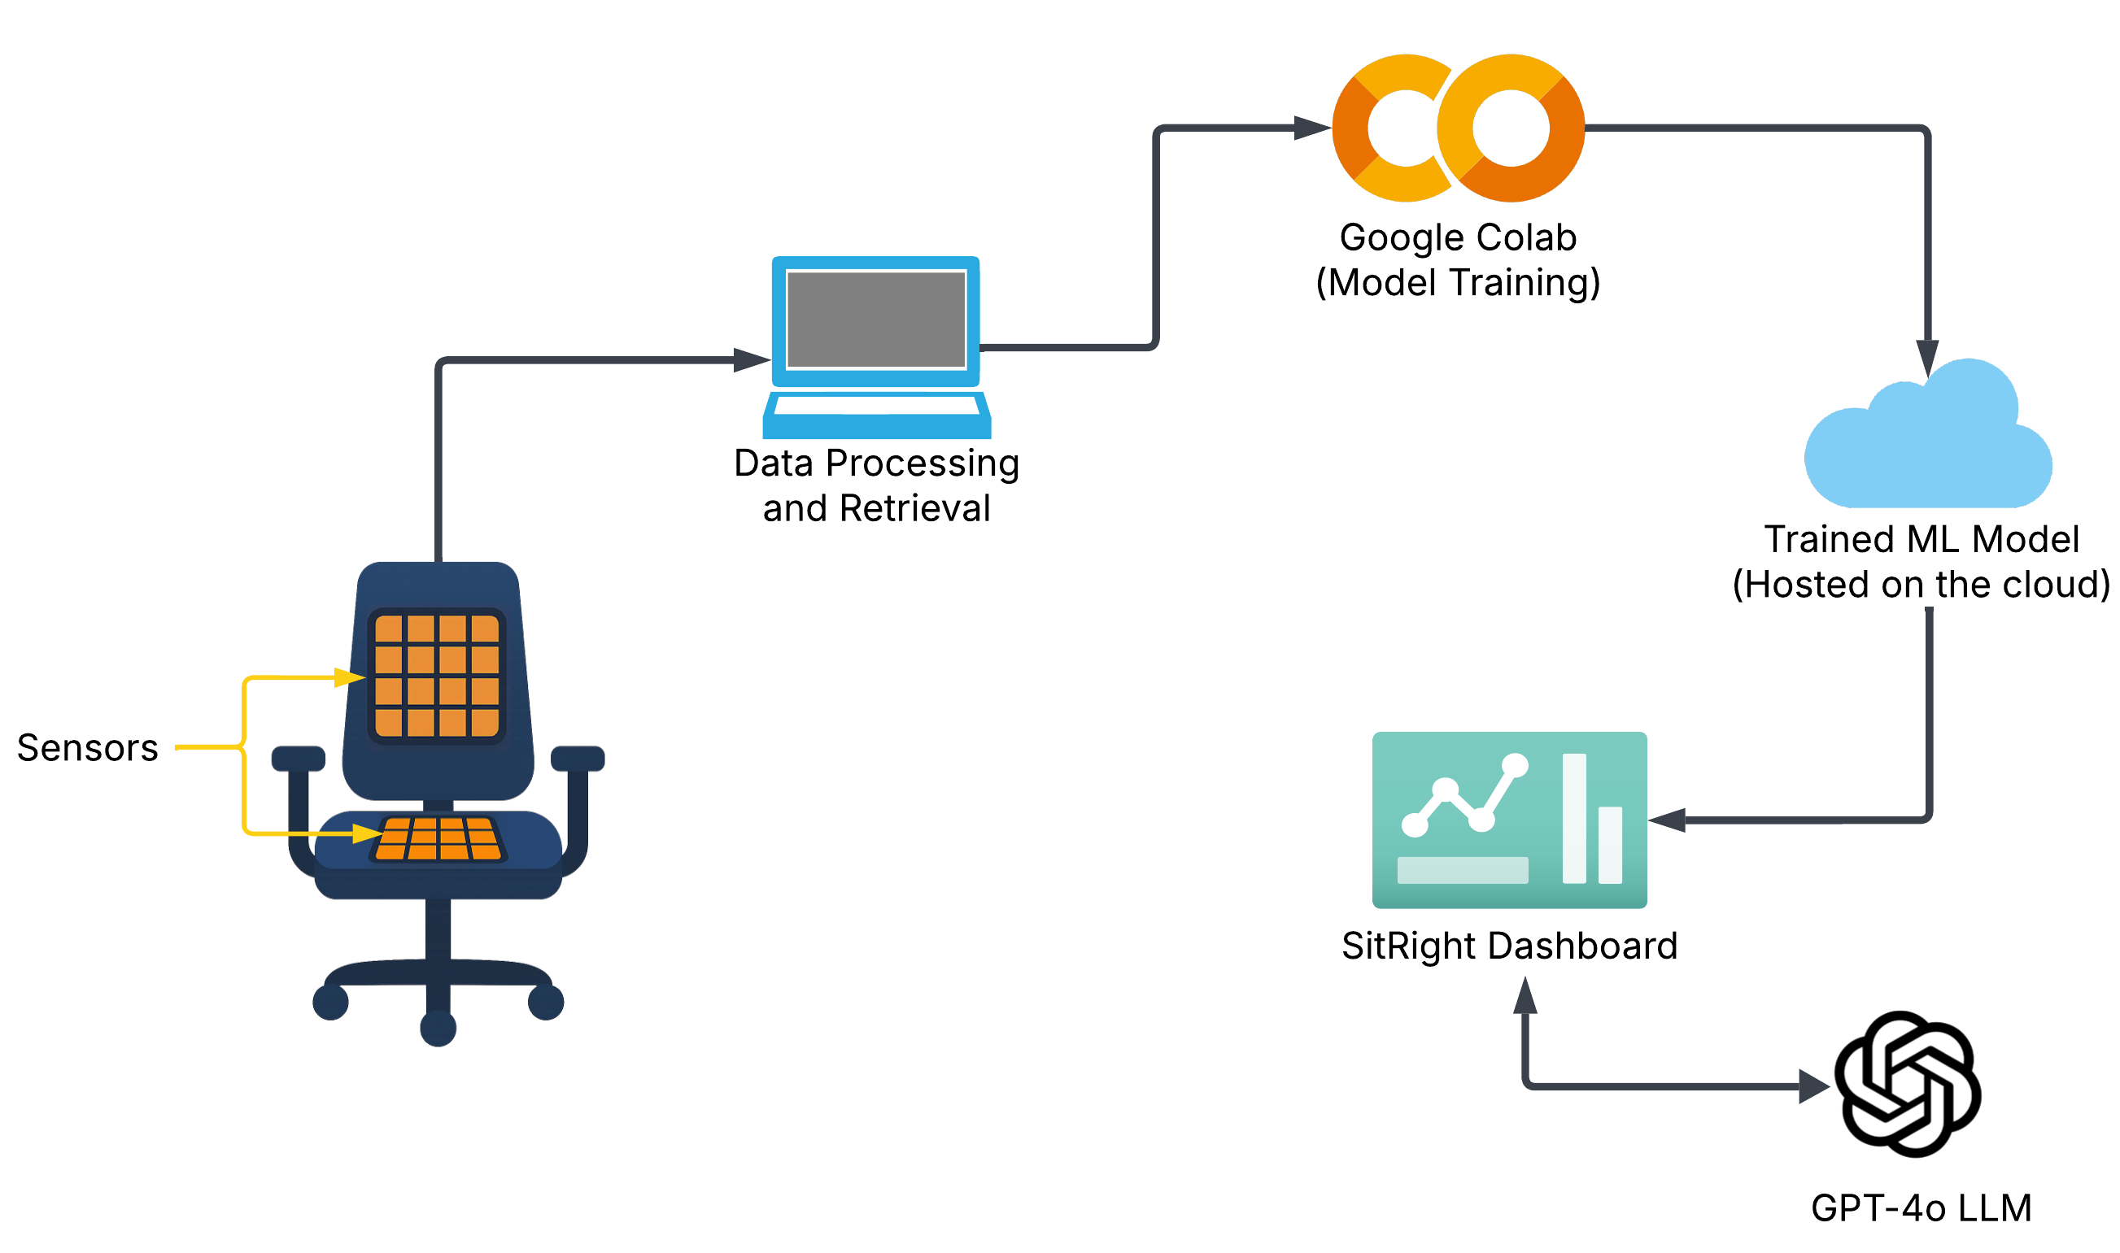

**Figure 2**. The entire system model of our proposed smart-sensing chair system.

3.2 Sensor Array and Data Collection

3.2.1 Sensor Array Specifications

The CONFORMat system developed by Tekscan was selected for our smart-sensing chair application due to its high resolution and its popular use within biomedical research applications [45]. Each sensor mat comprises of 1024 independent pressure units (32x32) distributed over a 471.4 mm x 471.4 mm area. The value for each pressure unit ranges between 0 and 255. Additionally, integrated into each sensor mat is its data acquisition module, called the Evolution handle™ device, which facilitates the data transfer between the sensor array and a PC via a tethered USB cable with sampling rates up to 100 Hz. A summarised technical specification list is provided in Table 1 below.

**Table 1**. CONFORMat sensor mat’s full technical specifications [46]

|  |  |
| --- | --- |
| **Technical Specification** | **Details** |
| System Model | CER2 (CONFORMat Sensor) |
| Sensor Model | 5330 |
| Quantity | 2 |
| Sensing Area | 471.4 mm x 471.4 mm  (18.56 in. x 18.56 in.) |
| # of Sensing Elements | 2048 (1024 on each mat) |
| Pressure Range | 0-34 kPa (5 psi) |
| Spatial Resolution | 0.5 Sensel/cm2 (3.0 Sensels/in2) |
| Sampling Rate | Up to 100 Hz |

3.2.2 Experimental Setup

For the experiment, two CONFORMat pressure sensor arrays were used: one on the backrest and the other on the sitting cushion, as shown in Figure 3 below. The integration of both pressure sensor mats allowed us to comprehensively capture the individual’s entire spatial sitting data. The thin and flexible nature of the pressure sensor mats allowed them to be easily integrated into the chair’s surfaces without sacrificing sitting ergonomics and the user’s comfort.



**Figure 3**. An office chair equipped with two Tekscan CONFORMat Pressure Sensor Mats.

3.2.3 Data Collection

We took a different approach for the data collection stage, having only one individual involved in our experiment. It has been acknowledged that many similar studies involve having multiple volunteers assist in developing a generalised model for widespread applicability. In a real-world environment, these machine learning models might not be well-suited for certain individuals with uncommon body structures or deformities, significantly hampering their effectiveness. In our case, we want to explore the idea of having the machine learning model specifically trained for a specific individual, making it more precise and applicable. Furthermore, the individual who participated in the experiment was directed to sit in 19 different sitting postures highlighted in Figure 1. Each posture was sat on for approximately 25 seconds as we recorded and saved the sensor data. Figure 4 below provides a visual representation of the sensor data corresponding to the different sitting postures being adopted. Overall, a total of 151 frames of sensor data were captured for each given posture, equating to a sum of 2869 sets of data.



**Figure 4**. The capturing of 19 different sitting postures along with their pressure distribution representation.

3.2.4 Data Augmentation

As previously discussed, given that only one participant was involved in the data collection phase, we needed to increase our entire dataset, improve the machine learning model’s robustness, and reduce the risk of overfitting. Hence, we opted to augment our dataset by applying a random combination of transformations: noise, shift, rotation, random erasing, and elastic deformation. Figure 5 shows an example of each transformation applied to an upright sitting posture data, and the parameters for each transformation are shown in Table 2 below.

The noise transformation aims to replicate a real-world scenario where environmental factors such as temperature, electromagnetic interference, humidity, and user clothing could negatively alter the sensor readings. The shift transformation accounts for a scenario where individuals are not perfectly seated in the centre of the seat’s cushion or when the sensors have been slightly shifted from their centre position. The rotational transformation considers periods where the user might be maintaining a particular posture but in a slightly rotated manner, or if the sensors were to be slightly rotated off their intended place, which might be a common issue. The random erasing transformation arbitrarily removes certain sections of the sensor reading, replicating certain areas of the sensor that are faulty or partially blocked. Finally, the elastic deformation slightly deforms the sensor readings to account for a scenario wherein there are minimal variations in a user’s body structure over time.



**Figure 5**. A series of examples of data augmentation being used. **(1) Original –** an upright posture without transformation. **(2) Noise –** an upright posture with added noise. **(3) Shift –** an upright posture shifted to the left. **(4)** **Rotation –** an upright posture rotated counterclockwise. **(5) Random Erasing** – randomly erases certain sections of the upright posture data. **(6) Elastic Deformation** – elastically smoothens the upright posture data.

**Table 2.** A summary of the transformation techniques that were used to augment the dataset.

|  |  |
| --- | --- |
| **Transformation** | **Parameters** |
| Noise | Gaussian Noise (σ = 10, μ = 0) |
| Shift | x-shift = ± 10 pixels  y-shift = ± 10 pixels |
| Rotation | ±30 degrees |
| Random Erasing | area = 10% |
| Elastic Deformation | alpha=48, sigma=8 |

Applying these transformations ensured that there are added varieties in the dataset, further improving the machine learning model's robustness. Additionally, this technique allowed us to inflate the size of our training dataset from 2302 to 8607, increasing the variability across each type of posture. Figure 6 below compares the standard deviation measurements between the original and augmented datasets. The box plots below represent the statistical variation across both datasets, the original and augmented datasets shown in blue and red box plots, respectively. The whiskers and the outliers extruding from each box plot are the participants' natural movements captured during the data collection stage. The figure shows that the augmented dataset introduces greater variability than the original dataset due to the added transformations. The increased variability in the augmented data aims to enhance the machine learning model’s robustness and prevent the risk of overfitting, given that only one participant was involved in the data collection.

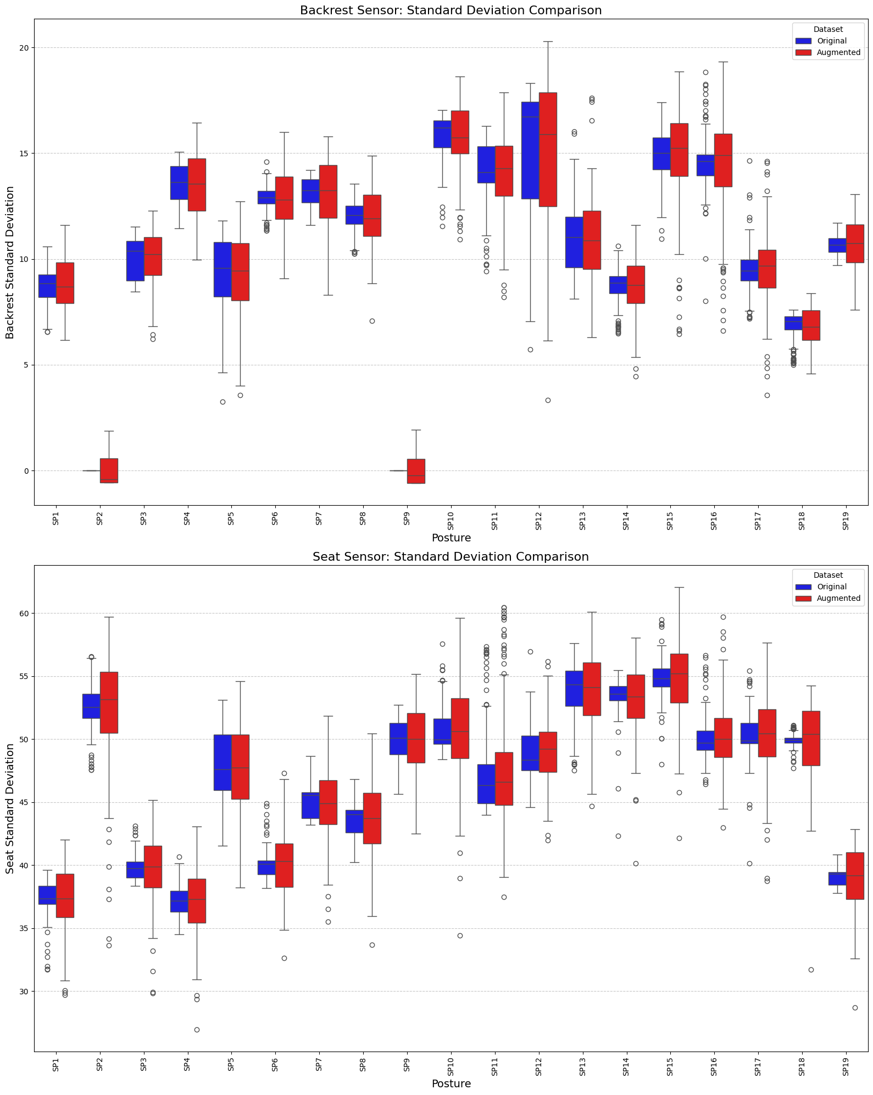

**Figure 6**. A comparison of the standard deviation between the original and the augmented dataset.

3.3 Machine Learning Algorithms for Posture Classification

There is no doubt that the choice of machine learning for classifying multiple sitting patterns plays a crucial role in the success of smart-sensing chair systems. Therefore, it must be made with careful consideration and sound rationale. In a previous review paper, we highlighted a popular trend in using specific machine learning models, including Decision Trees, Random Forests, Support Vector Machines, K-Nearest Neighbours, and Convolutional Neural Networks [10].

3.3.1 Decision Tree

A decision tree is a supervised machine learning approach which is based on a series of decision rulesets that influence its predicted outcome. A decision tree has a hierarchical tree-like structure composed of a root node, an internal node, and a leaf node. The root node is the starting point of the tree and holds. The internal node represents a given condition or a given attribute, while the leaf node holds a specified value, symbolising all possible outcomes. The main underlying issue with decision trees is that they are widely prone to biases and overfitting as the tree grows exponentially [47].

3.3.2 Random Forest

Random forest is a machine-learning model that is commonly used for regression and classification-type predictions. The random forest algorithm is composed of multiple decision trees which work together as an ensemble to output a final prediction. Each decision tree in the ensemble is trained on a random data subset, which is retrieved from a training sample using a method called bagging or bootstrap aggregating. This method enforces the randomness of the data, making it unsusceptible to biases and overfitting among the trees. The random forest algorithm has three hyperparameters that must be considered: the node size, the number of trees, and the number of features. The final prediction is made by aggregating the outputs of all decision trees. Majority voting is typically used for classification-type predictions and group averaging for regression-type predictions [48,49].

3.3.3 Support Vector Machine (SVM)

Support Vector Machine is a supervised machine learning model that finds the optimal hyperplane or dividing line that determines the boundaries between multiple data points based on defined classes. SVM aims to calculate the most optimal margin, which is defined as the distance between the hyperplane and the closest data points between multiple classes. For more complex and non-linear datasets, SVM uses kernel functions which perform a series of data transformations into a higher-dimensional space, making it easier to separate the data points into separate classes [50].

3.3.4 K-Nearest Neighbor (KNN)

K-Nearest Neighbor is another supervised machine-learning technique that is used to solve classification and regression problems. The KNN algorithm works on the principle of making predictions based on the distance metric of a data point concerning the closest training data point. This means that the proximity between a data point and the K’s closest neighbour greatly determines its predictions. Instead of undergoing training as other models, KNN stores the training dataset in memory and performs all the necessary computations during the prediction phase. Hence, the scalability of KNN becomes a prominent issue as the size of the training dataset grows exponentially [51].

3.3.5 Convolutional Neural Networks (CNN)

The Convolutional Neural Network (CNN) is a supervised neural network comprised of multiple node layers: an input layer, one or more hidden layers, and an output layer. Each node across different layers is interconnected with one another and has an assigned weight and threshold value. The convolution layer is an essential layer of CNN as it extracts relevant patterns or features by applying filters (convolution kernels) [52].

3.4 Training and Validation Approach

We divided the dataset into two groups to train and evaluate the machine learning model. 80% of the dataset was allocated towards training the machine learning model, while the remaining 20% was used to validate the performance and accuracy of each machine learning model. After a series of trial-and-error experiments, we finetuned each model with the following parameters, which were then used in training the model shown in Table 3 below. The results were analysed using the confusion matrix, which assesses the accuracy of each model by comparing the predicted value with the true value over a series of key criteria, which are as follows: True Positives (TPs), True Negatives (TNs), False Positives (FPs), and False Negatives (FNs).

**Table 3**. Machine Learning Model Training Parameters

|  |  |
| --- | --- |
| **Model** | **Parameters** |
| Decision Tree | min_samples_leaf=1  max_depth=10 |
| Random Forest | max_depth=10  min_samples_leaf=1 |
| SVM | c=1 |
| KNN | n_neighbors=5  weights=uniform |
| CNN | Conv2D (32 filters, (3,3), ‘relu’)  MaxPooling2D ((2,2))  Conv2D (64 filters, (3,3), ‘relu’)  MaxPooling2D ((2,2))  Flatten  Dense (128 units, ‘relu’)  Dense (num_classes, ‘softmax’)  Compilation: Optimizer=’adam’, Loss=’categorical_crossentropy’, Metric=’accuracy’ |

3.5 Posture Shape Deviation using Constrained Procrustes Analysis

Quantifying the degree to which a given sitting posture deviates from an intended posture is crucial in the development of our feedback system. To achieve this, we adopted Procrustes Analysis – a statistical shape analysis algorithm used to compare differences between 2 distinct shapes by performing optimal transformational procedures such as scaling, translation and rotations to best align with the reference shape, thereby minimising the sum of the squared distances between 2 sets of data points [53]. Once the shapes are closely aligned, the Procrustes Distance (PD) is then calculated using the simplified formula below:

$$PD\left(X, Y\right)= \sqrt{\sum_{i=1}^{n}{{|\left|X_{i}-Y_{i}\right||}^{2}}}$$

where (X, Y) represents the k-dimensional shapes, (n) denotes the number of landmark points, and (${|\left|X_{i}-Y_{i}\right||}^{2}$) represents the Euclidean distances between the $i^{th}$ landmarks across the $X_{i}$ $Y_{i}$ samples.

For our approach, we adopted a constraint-based Procrustes Analysis by selectively disabling a specific set of irrelevant geometric transformations, such as rotational, scaling and tilt. This allowed us to preserve the geometric properties of the sitting posture and retrieve the true spatial differences between the two sitting postures. Furthermore, the only geometric transformation allowed was the translational shift along the x and y axes.

We conducted a series of experiments to validate the concept of our constraint-based Procrustes analysis in determining a posture’s deviation from a reference posture, as seen in Figure 7 below. We created a sample sensor seat data replicating an upright sitting posture. After applying a series of transformations along each step, we recorded the Procrustes distance. As expected, predefined shifts along the horizontal axis don’t affect the Procrustes distance. Moreover, a gradual increase in postural tilt and rotations results in a greater Procrustes distance value.

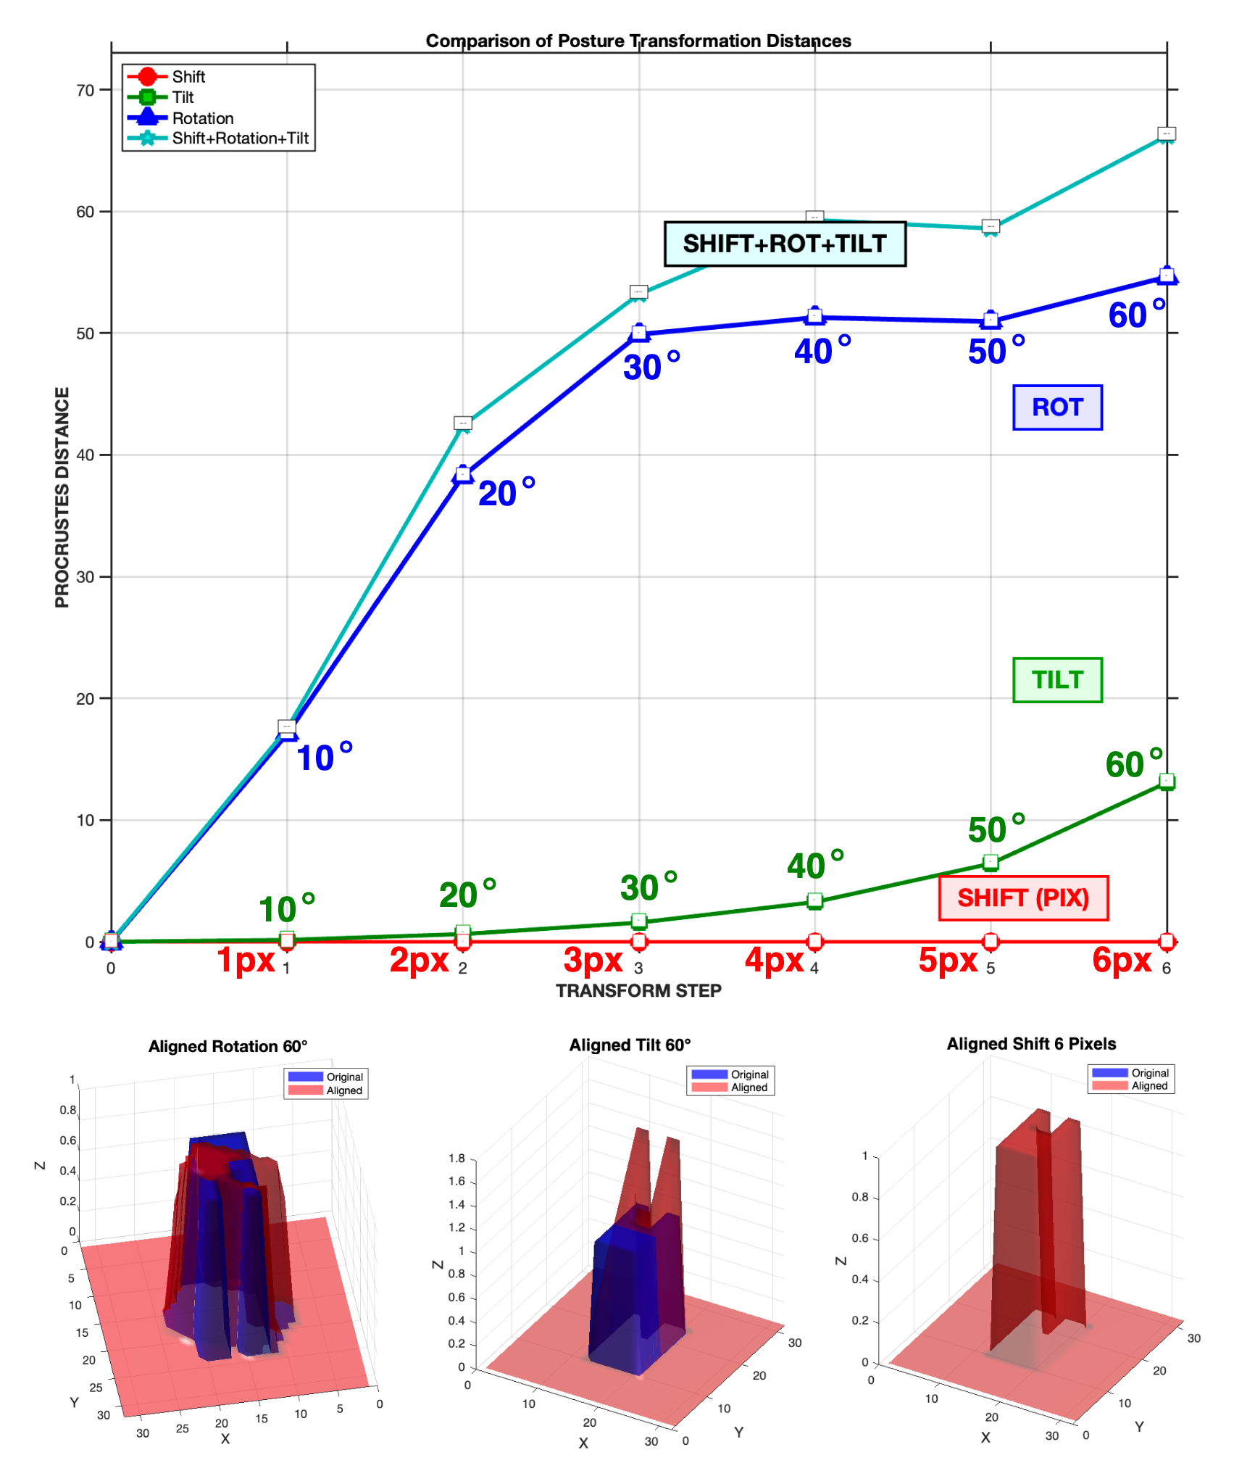

**Figure 7**. A comparison of the Procrustes distances resulting from 3 different transformations (tilt, shift, and rotation).

3.6 GPT Model for Personalised Recommendations

To generate personalised and tailored recommendations for the end user, we leveraged OpenAI’s Generative Pre-Trained Transformer (GPT) model as our core pillar. GPT is an LLM that has been pre-trained on a plethora of data from the internet, making it very useful in many areas, such as data analysis, language learning, pattern matching, and sentiment analysis, to name a few [54]. OpenAI has a variety of models available, for our research study, we decided upon the GPT-4o model since it was one of their most capable and flagship models available. The model parameters were fine-tuned using the following settings shown in Table 4. Furthermore, the model was provided with a realistic set of an individual’s historical sitting postural dataset and a system prompt that instructed it to identify recurring postural issues and recommend better postural habits to improve one’s health and well-being. A sample of the historical dataset being passed to the model can be seen in Figure 8 below. Each data entry contains the detected sitting posture and the corresponding start and end timestamps.

**Table 4**. OpenAI GPT-4o’s Parameters

|  |  |
| --- | --- |
| **Parameter** | **Value** |
| Model | GPT-4o |
| Temperature | 1 |
| Max Token | 256 |
| Top P | 1 |
| Friction Penalty | 0 |
| Presence Penalty | 0 |



**Figure 8**. A sample historical postural dataset along with its timestamp.

3.8 Web-Based Feedback Platform

We built the “SitRight” dashboard, a web-based application designed to effectively provide relevant information about one’s sitting habits. The web application was developed using Flutter (Dart), an open-source framework that supports the development of multi-platform applications such as iOS, Android, and Desktop under a single codebase. We also developed a serverless backend application using the Python programming language, which integrated with our trained CNN model to predict the posture that was being adopted. Furthermore, we then utilized OpenAI’s GPT-4o Large Language Model (LLM) to generate personalized recommendations based on historical postural data. The block diagram in Figure 9 below contains the three main components used to develop our posture feedback system.



**Figure 9**. Block diagram of our proposed posture feedback system

In the way it was designed, the feedback application doesn’t retrieve real-time data from the pressure sensor mats. Instead, we programmatically integrated the previously collected postural sensor dataset and fed it into the posture feedback system to replicate it coming directly from the sensor mat through wireless connectivity. Figures 10 and 11 are screenshots of the feedback system. Table 5 describes each section of the proposed system.



**Figure 10**. First screenshot of the “SitRight” Dashboard



**Figure 11**. Second screenshot of the “SitRight” Dashboard

**Table 5**. Description for labels in Figures 10 and 11

|  |  |
| --- | --- |
| **ID** | **Description** |
| 1 | Pressure Sensor Mat Visualization |
| 2 | A demonstration of the sitting posture being adopted |
| 3 | Simulation Control Panel |
| 4 | A chart visualizing the different sitting postures being adopted |
| 5 | A chart showing the quality of the sitting over time based on historical data |
| 6 | Pie chart displaying the statistics of the sitting posture being adopted |
| 7 | The predicted posture from our trained CNN model |
| 8 | A summarized recommendation generated by the GPT-4o model based historical data |

4. Results and Discussion

4.1 Performance of the Machine Learning Algorithm

The accuracy and performance of each machine learning model were evaluated by utilising 20% of the entire gathered dataset towards testing. Furthermore, we directly compared five different machine learning models: Decision Tree, Random Forest, SVM, KNN, and CNN. Table 5 summarises each machine learning model’s overall accuracy in classifying all 19 sitting postures. It was seen that the Decision tree had the lowest performance, achieving an accuracy of 83.44%, while CNN was the best-performing model, having an accuracy of 99.65%.

**Table 6.** Classification of the machine learning models using the testing dataset.

|  |  |  |
| --- | --- | --- |
| **Model** | **Accuracy** | **F1 Score** |
| Decision Tree | 83.67% | 0.83 |
| Random Forest | 98.67 % | 0.98 |
| SVM | 99.02% | 0.99 |
| KNN | 97.92% | 0.97 |
| CNN | 99.65% | 0.99 |

4.2 Confusion Matrix result for CNN

Given that the CNN model had the highest classification accuracy among the other machine learning models tested, we plotted its confusion matrix, as shown in Figure 10 below. As expected, for the most part, CNN can distinguish between all 19 distinct sitting postures. Interestingly, CNN had the most errors distinguishing between SP8 (leaning forward with backrest) and SP10 (left ankle rest on the right leg), where it was misclassified a handful of times, most likely due to their striking similarity in spatial shape.



**Figure 12**. Confusion Matrix for the CNN model.

4.3 Comparison between the Pressure Sensor Density and Machine Learning Model Accuracy

Given that both of our (32x32) pressure sensor mats are of a high resolution (comprised of 1024 pressure units), we needed to understand whether a resolution of this magnitude is necessary to classify multiple sitting postures accurately. The main question that needs to be addressed is whether a lower sensor resolution can achieve a similar level of accuracy as a higher-resolution sensor. To answer this question, we experimented further by programmatically lowering the original (32x32) sensor resolution using the bilinear interpolation algorithm. Multiple simulated sensor sizes (2x2, 3x3, 5x5, 10x10, 20x20, 25x25, 32x32) were compared against different machine learning models. There is an apparent relationship between the classification accuracy and the sensor’s resolution, as shown in Figure 11. Overall, it seen that the classification accuracy is largely dependent on the sensor resolution. As the sensor’s resolution increases, the classification accuracy increases for most machine learning models. A majority of the machine learning models struggled with lower resolutions, such as those of 2x2, 3x3, and 5x5 resolutions. This suggests that these resolutions do not provide adequate information or feature sets for the machine learning models to identify different sitting postures reliably. As a result, this caused the models to perform relatively poorly compared to those of higher resolutions. It is seen that the 10x10 array size is sufficient for most machine-learning models to distinguish between different sitting postures with near-perfect accuracy. Machine models such as the CNN, Random Forest, SVM and KNN were able to achieve accuracies upwards of 98%, at par with even higher sensor resolution sizes such as the (20x20), (25x25), and (32x32). Therefore, this suggests that a (10x10) resolution size can capture one’s sitting postures without compromising accuracy.



**Figure 13**. A graph comparing the accuracies of different machine learning models for various sensor sizes.

4.5 Evaluation of AI Recommendation

We evaluated the LLM’s generated recommendations by experimenting with varying user prompts. Once contented with our formulated prompt message, we created a simple test environment to analyse the LLM’s ability to produce accurate, well-defined recommendations. In this test environment, we create a pre-recorded scenario of an individual's historical posture timeline over an hour period, slouching for an extended period, as shown in Figure 14 below. The prompt tab within the figure shows the prompt sent to the model, and the Recommendation tab shows the results generated by the model. Overall, it can be seen that the model accurately highlighted that the individual was slouching for an extended period. It also provided additional suggestions to improve one’s sitting habits. After further tests like these, we observe that the LLM's responses were sometimes quite generic; this signals that there are potential areas for us to improve the prompt being used.



**Figure 14**. A simulated experiment of an individual’s posture timeline leaning left for an extended period, along with the LLM’s given prompt and generated recommendation.

4.6 Evaluation of our Constrained Procrustes Algorithm

To evaluate our constrained Procrustes algorithm approach, we calculated the Procrustes distances across all 19 sitting postures using the upright posture (SP1) as the reference posture. Figure 15 below is a bar graph that displays the calculated distance measurement for each sitting posture. Overall, it was seen that sitting postures with similar shape characteristics to the reference upright posture, such as SP3, SP4, SP6 and SP11, have the smallest Procrustes distances, ranging from values within 699.40 to 833.47. On the other hand, postures that involved a significant shift in overall weight distribution or those with extreme leaning derived procrustes distance values. This is very apparent, particularly with postures SP2, SP9, and SP12, having 1884.69, 1794.22, and 2068.46, respectively.

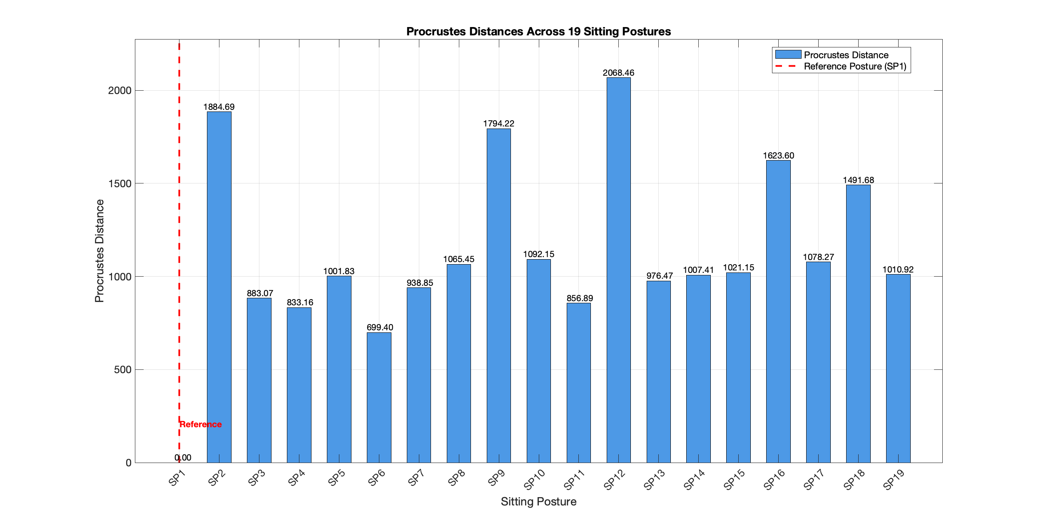

**Figure 15**. The Procrustes Distances across all 19 sitting postures.

5. Conclusions

In this paper, we developed a smart-sensing chair system capable of classifying 19 sitting postures using two 32x32 pressure sensor mats. We also examined and compared five different machine learning algorithms (Decision Tree, Random Forest, SVM, KNN, and CNN). Overall, the CNN model achieved the highest classification accuracy with a value of 99.65%, in contrast to the Decision tree, which had the lowest score at 83.67%. Additionally, a comprehensive web-based feedback system was developed to provide the end user with valuable information and insight regarding the adopted sitting patterns using OpenAI GPT-4o model to generate insightful recommendations and actionable plans based on historical data. We also incorporated a constrained Procrustes Analysis approach to determine how much a given sitting posture deviates from a reference posture.

6. Future Directives

In a future study, it would be valuable to compare the performance of our user-tailored model approach with a generalised model pre-trained against a wide set of volunteers. Currently, our web-based feedback system doesn’t collect real-time posture data from our pressure sensor array; hence, it would be pivotal to have the sensor data streamed wirelessly using an IoT protocol directly to our web-based feedback system. Integrating additional sensors such as ECGS and other health sensors could provide a comprehensive view into one’s overall health and sitting lifestyle.

It would be beneficial to collect feedback on the proposed “SitRight” dashboard and have healthcare professionals in the musculoskeletal research field evaluate the recommendations generated by the LLM to ensure that they are valid and medically sound.

**Author Contributions:** <Author’s contributions>

**Funding:** This work was partly supported by the University of South Wales (USW) QR fund (ref: 104607.13.1125), RIS funding (ref: 104790.1125), and Cardiff & Vale University Health Board, Rehabilitation Engineering Unit (REU), contributions (ref: 103914.13.1122).

**Institutional Review Board Statement:** Not Applicable.

**Informed Consent Statement:** Not Applicable.

**Data Availability Statement:** Data will be available upon request.

**Acknowledgements:** The authors would like to thank the University of South Wales and Cardiff & Vale University Health Board, REU, for supporting the project.

**Conflicts of Interest:** The authors declare no conflicts of interest.

References

1. Daneshmandi, H.; Choobineh, A.; Ghaem, H.; Karimi, M. Adverse Effects of Prolonged Sitting Behavior on the General Health of Office Workers. *J Lifestyle Med* **2017**, *7*, 69–75, doi:10.15280/jlm.2017.7.2.69.

2. Keskin, Y. Correlation between Sitting Duration and Position and Lumbar Pain among Office Workers. *Haydarpasa Numune Med J* **2019**, doi:10.14744/hnhj.2019.04909.

3. *Global Status Report on Physical Activity 2022*; World Health Organization: Geneva, 2022; ISBN 978-92-4-005915-3.

4. Yang, L.; Lu, X.; Yan, B.; Huang, Y. Prevalence of Incorrect Posture among Children and Adolescents: Finding from a Large Population-Based Study in China. *iScience* **2020**, *23*, 101043, doi:10.1016/j.isci.2020.101043.

5. Kett, A.R.; Sichting, F.; Milani, T.L. The Effect of Sitting Posture and Postural Activity on Low Back Muscle Stiffness. *Biomechanics* **2021**, *1*, 214–224, doi:10.3390/biomechanics1020018.

6. Ágústsson, A.; Sveinsson, Þ.; Rodby-Bousquet, E. The Effect of Asymmetrical Limited Hip Flexion on Seating Posture, Scoliosis and Windswept Hip Distortion. *Research in Developmental Disabilities* **2017**, *71*, 18–23, doi:10.1016/j.ridd.2017.09.019.

7. Susilowati, I.H.; Kurniawidjaja, L.M.; Nugraha, S.; Nasri, S.M.; Pujiriani, I.; Hasiholan, B.P. The Prevalence of Bad Posture and Musculoskeletal Symptoms Originating from the Use of Gadgets as an Impact of the Work from Home Program of the University Community. *Heliyon* **2022**, *8*, e11059, doi:10.1016/j.heliyon.2022.e11059.

8. Stephens, M.; Bartley, C.A. Understanding the Association between Pressure Ulcers and Sitting in Adults What Does It Mean for Me and My Carers? Seating Guidelines for People, Carers and Health & Social Care Professionals. *Journal of Tissue Viability* **2018**, *27*, 59–73, doi:10.1016/j.jtv.2017.09.004.

9. Benatti, F.B.; Ried-Larsen, M. The Effects of Breaking up Prolonged Sitting Time: A Review of Experimental Studies. *Medicine & Science in Sports & Exercise* **2015**, *47*, 2053–2061, doi:10.1249/MSS.0000000000000654.

10. Odesola, D.F.; Kulon, J.; Verghese, S.; Partlow, A.; Gibson, C. Smart Sensing Chairs for Sitting Posture Detection, Classification, and Monitoring: A Comprehensive Review. *Sensors* **2024**, *24*, 2940, doi:10.3390/s24092940.

11. Vermander, P.; Mancisidor, A.; Cabanes, I.; Perez, N. Intelligent Systems for Sitting Posture Monitoring and Anomaly Detection: An Overview. *J NeuroEngineering Rehabil* **2024**, *21*, 28, doi:10.1186/s12984-024-01322-z.

12. Cajamarca, G.; Rodríguez, I.; Herskovic, V.; Campos, M.; Riofrío, J.C. StraightenUp+: Monitoring of Posture during Daily Activities for Older Persons Using Wearable Sensors. *Sensors* **2018**, *18*, 3409, doi:10.3390/s18103409.

13. Ardito, M.; Mascolo, F.; Valentini, M.; Dell’Olio, F. Low-Cost Wireless Wearable System for Posture Monitoring. *Electronics* **2021**, *10*, 2569, doi:10.3390/electronics10212569.

14. Upright Upright Go 2 Available online: https://store.uprightpose.com/products/upright-go2.

15. Estrada, J.; Vea, L. Sitting Posture Recognition for Computer Users Using Smartphones and a Web Camera. In Proceedings of the TENCON 2017 - 2017 IEEE Region 10 Conference; IEEE: Penang, November 2017; pp. 1520–1525.

16. Liu, B.; Li, Y.; Zhang, S.; Ye, X. Healthy Human Sitting Posture Estimation in RGB-D Scenes Using Object Context. *Multimed Tools Appl* **2017**, *76*, 10721–10739, doi:10.1007/s11042-015-3189-x.

17. Estrada, J.E.; Vea, L.A.; Devaraj, M. Modelling Proper and Improper Sitting Posture of Computer Users Using Machine Vision for a Human–Computer Intelligent Interactive System during COVID-19. *Applied Sciences* **2023**, *13*, 5402, doi:10.3390/app13095402.

18. Tan, H.Z.; Slivovsky, L.A.; Pentland, A. A Sensing Chair Using Pressure Distribution Sensors. *IEEE/ASME Trans. Mechatron.* **2001**, *6*, 261–268, doi:10.1109/3516.951364.

19. Wang, J.; Hafidh, B.; Dong, H.; El Saddik, A. Sitting Posture Recognition Using a Spiking Neural Network. *IEEE Sensors J.* **2021**, *21*, 1779–1786, doi:10.1109/JSEN.2020.3016611.

20. Tsai, M.-C.; Chu, E.T.-H.; Lee, C.-R. An Automated Sitting Posture Recognition System Utilizing Pressure Sensors. *Sensors* **2023**, *23*, 5894, doi:10.3390/s23135894.

21. Matuska, S.; Paralic, M.; Hudec, R. A Smart System for Sitting Posture Detection Based on Force Sensors and Mobile Application. *Mobile Information Systems* **2020**, *2020*, 1–13, doi:10.1155/2020/6625797.

22. Martínez-Estrada, M.; Vuohijoki, T.; Poberznik, A.; Shaikh, A.; Virkki, J.; Gil, I.; Fernández-García, R. A Smart Chair to Monitor Sitting Posture by Capacitive Textile Sensors. *Materials* **2023**, *16*, 4838, doi:10.3390/ma16134838.

23. Pereira, L.; Plácido Da Silva, H. A Novel Smart Chair System for Posture Classification and Invisible ECG Monitoring. *Sensors* **2023**, *23*, 719, doi:10.3390/s23020719.

24. Jeong, H.; Park, W. Developing and Evaluating a Mixed Sensor Smart Chair System for Real-Time Posture Classification: Combining Pressure and Distance Sensors. *IEEE J. Biomed. Health Inform.* **2021**, *25*, 1805–1813, doi:10.1109/JBHI.2020.3030096.

25. Fragkiadakis, E.; Dalakleidi, K.V.; Nikita, K.S. Design and Development of a Sitting Posture Recognition System. In Proceedings of the 2019 41st Annual International Conference of the IEEE Engineering in Medicine and Biology Society (EMBC); IEEE: Berlin, Germany, July 2019; pp. 3364–3367.

26. Javaid, A.; Abbas, A.; Arshad, J.; Rahmani, M.K.I.; Chauhdary, S.T.; Jaffery, M.H.; Banga, A.S. Force Sensitive Resistors-Based Real-Time Posture Detection System Using Machine Learning Algorithms. *CMC* **2023**, *77*, 1795–1814, doi:10.32604/cmc.2023.044140.

27. Ma, C.; Li, W.; Gravina, R.; Fortino, G. Posture Detection Based on Smart Cushion for Wheelchair Users. *Sensors* **2017**, *17*, 719, doi:10.3390/s17040719.

28. Ma, C.; Li, W.; Gravina, R.; Du, J.; Li, Q.; Fortino, G. Smart Cushion-Based Activity Recognition: Prompting Users to Maintain a Healthy Seated Posture. *IEEE Syst. Man Cybern. Mag.* **2020**, *6*, 6–14, doi:10.1109/MSMC.2019.2962226.

29. Fu, T.; Macleod, A. IntelliChair: An Approach for Activity Detection and Prediction via Posture Analysis. In Proceedings of the 2014 International Conference on Intelligent Environments; IEEE: China, June 2014; pp. 211–213.

30. Wan, Q.; Zhao, H.; Li, J.; Xu, P. Hip Positioning and Sitting Posture Recognition Based on Human Sitting Pressure Image. *Sensors* **2021**, *21*, 426, doi:10.3390/s21020426.

31. Roh, J.; Park, H.; Lee, K.; Hyeong, J.; Kim, S.; Lee, B. Sitting Posture Monitoring System Based on a Low-Cost Load Cell Using Machine Learning. *Sensors* **2018**, *18*, 208, doi:10.3390/s18010208.

32. Feng, L.; Li, Z.; Liu, C. Are You Sitting Right?-Sitting Posture Recognition Using RF Signals. In Proceedings of the 2019 IEEE Pacific Rim Conference on Communications, Computers and Signal Processing (PACRIM); IEEE: Victoria, BC, Canada, August 2019; pp. 1–6.

33. Zemp, R.; Tanadini, M.; Plüss, S.; Schnüriger, K.; Singh, N.B.; Taylor, W.R.; Lorenzetti, S. Application of Machine Learning Approaches for Classifying Sitting Posture Based on Force and Acceleration Sensors. *BioMed Research International* **2016**, *2016*, 1–9, doi:10.1155/2016/5978489.

34. Bourahmoune, K.; Ishac, K.; Amagasa, T. Intelligent Posture Training: Machine-Learning-Powered Human Sitting Posture Recognition Based on a Pressure-Sensing IoT Cushion. *Sensors* **2022**, *22*, 5337, doi:10.3390/s22145337.

35. Kim, Y.; Son, Y.; Kim, W.; Jin, B.; Yun, M. Classification of Children’s Sitting Postures Using Machine Learning Algorithms. *Applied Sciences* **2018**, *8*, 1280, doi:10.3390/app8081280.

36. Fan, Z.; Hu, X.; Chen, W.-M.; Zhang, D.-W.; Ma, X. A Deep Learning Based 2-Dimensional Hip Pressure Signals Analysis Method for Sitting Posture Recognition. *Biomedical Signal Processing and Control* **2022**, *73*, 103432, doi:10.1016/j.bspc.2021.103432.

37. Chen, K. Sitting Posture Recognition Based on OpenPose. *IOP Conf. Ser.: Mater. Sci. Eng.* **2019**, *677*, 032057, doi:10.1088/1757-899X/677/3/032057.

38. Ran, X.; Wang, C.; Xiao, Y.; Gao, X.; Zhu, Z.; Chen, B. A Portable Sitting Posture Monitoring System Based on a Pressure Sensor Array and Machine Learning. *Sensors and Actuators A: Physical* **2021**, *331*, 112900, doi:10.1016/j.sna.2021.112900.

39. Luna-Perejón, F.; Montes-Sánchez, J.M.; Durán-López, L.; Vazquez-Baeza, A.; Beasley-Bohórquez, I.; Sevillano-Ramos, J.L. IoT Device for Sitting Posture Classification Using Artificial Neural Networks. *Electronics* **2021**, *10*, 1825, doi:10.3390/electronics10151825.

40. Ren, X.; Yu, B.; Lu, Y.; Zhang, B.; Hu, J.; Brombacher, A. LightSit: An Unobtrusive Health-Promoting System for Relaxation and Fitness Microbreaks at Work. *Sensors* **2019**, *19*, 2162, doi:10.3390/s19092162.

41. Cai, W.; Zhao, D.; Zhang, M.; Xu, Y.; Li, Z. Improved Self-Organizing Map-Based Unsupervised Learning Algorithm for Sitting Posture Recognition System. *Sensors* **2021**, *21*, 6246, doi:10.3390/s21186246.

42. Cho, H.; Choi, H.-J.; Lee, C.-E.; Sir, C.-W. Sitting Posture Prediction and Correction System Using Arduino-Based Chair and Deep Learning Model. In Proceedings of the 2019 IEEE 12th Conference on Service-Oriented Computing and Applications (SOCA); IEEE: Kaohsiung, Taiwan, November 2019; pp. 98–102.

43. Ishac, K.; Suzuki, K. LifeChair: A Conductive Fabric Sensor-Based Smart Cushion for Actively Shaping Sitting Posture. *Sensors* **2018**, *18*, 2261, doi:10.3390/s18072261.

44. Ren, X.; Yu, B.; Lu, Y.; Chen, Y.; Pu, P. HealthSit: Designing Posture-Based Interaction to Promote Exercise during Fitness Breaks. *International Journal of Human–Computer Interaction* **2019**, *35*, 870–885, doi:10.1080/10447318.2018.1506641.

45. Tekscan Tekscan Available online: https://www.tekscan.com (accessed on 8 October 2024).

46. Tekscan Body Pressure Measurement System (BPMS) - Research Available online: https://www.tekscan.com/products-solutions/systems/body-pressure-measurement-system-bpms-research.

47. Rokach, L.; Maimon, O. Decision Trees. In *Data Mining and Knowledge Discovery Handbook*; Maimon, O., Rokach, L., Eds.; Springer-Verlag: New York, 2005; pp. 165–192 ISBN 978-0-387-24435-8.

48. Cutler, A.; Cutler, D.R.; Stevens, J.R. Random Forests. In *Ensemble Machine Learning*; Zhang, C., Ma, Y., Eds.; Springer New York: New York, NY, 2012; pp. 157–175 ISBN 978-1-4419-9325-0.

49. IBM What Is Random Forest? Available online: https://www.ibm.com/topics/random-forest#:~:text=Random%20forest%20is%20a%20commonly,both%20classification%20and%20regression%20problems.

50. Awad, M.; Khanna, R. Support Vector Machines for Classification. In *Efficient Learning Machines*; Apress: Berkeley, CA, 2015; pp. 39–66 ISBN 978-1-4302-5989-3.

51. Cunningham, P.; Delany, S.J. K-Nearest Neighbour Classifiers - A Tutorial. *ACM Comput. Surv.* **2022**, *54*, 1–25, doi:10.1145/3459665.

52. Ghosh, A.; Sufian, A.; Sultana, F.; Chakrabarti, A.; De, D. Fundamental Concepts of Convolutional Neural Network. In *Recent Trends and Advances in Artificial Intelligence and Internet of Things*; Balas, V.E., Kumar, R., Srivastava, R., Eds.; Intelligent Systems Reference Library; Springer International Publishing: Cham, 2020; Vol. 172, pp. 519–567 ISBN 978-3-030-32643-2.

53. Vandeginste, B.G.M.; Massart, D.L.; Buydens, L.M.C.; De Jong, S.; Lewi, P.J.; Smeyers-Verbeke, J. Relations between Measurement Tables. In *Data Handling in Science and Technology*; Elsevier, 1998; Vol. 20, pp. 307–347 ISBN 978-0-444-82853-8.

54. Yenduri, G.; M, R.; G, C.S.; Y, S.; Srivastava, G.; Maddikunta, P.K.R.; G, D.R.; Jhaveri, R.H.; B, P.; Wang, W.; et al. Generative Pre-Trained Transformer: A Comprehensive Review on Enabling Technologies, Potential Applications, Emerging Challenges, and Future Directions 2023.

**Disclaimer/Publisher’s Note:** The statements, opinions and data contained in all publications are solely those of the individual author(s) and contributor(s) and not of MDPI and/or the editor(s). MDPI and/or the editor(s) disclaim responsibility for any injury to people or property resulting from any ideas, methods, instructions or products referred to in the content.